**DAY – 3 ASSIGNMENT – 5**

**Scrum Framework:**

Scrum is an **Agile framework** that helps teams work together to build products, especially software, in a flexible and efficient way. Instead of planning the entire project upfront, Scrum breaks the work into smaller pieces called **Sprints**, which are short cycles usually lasting 2 to 4 weeks. Each Sprint produces a working piece of the product that can be reviewed and improved in the next Sprint. This approach allows teams to adapt quickly to changing requirements and deliver value continuously.

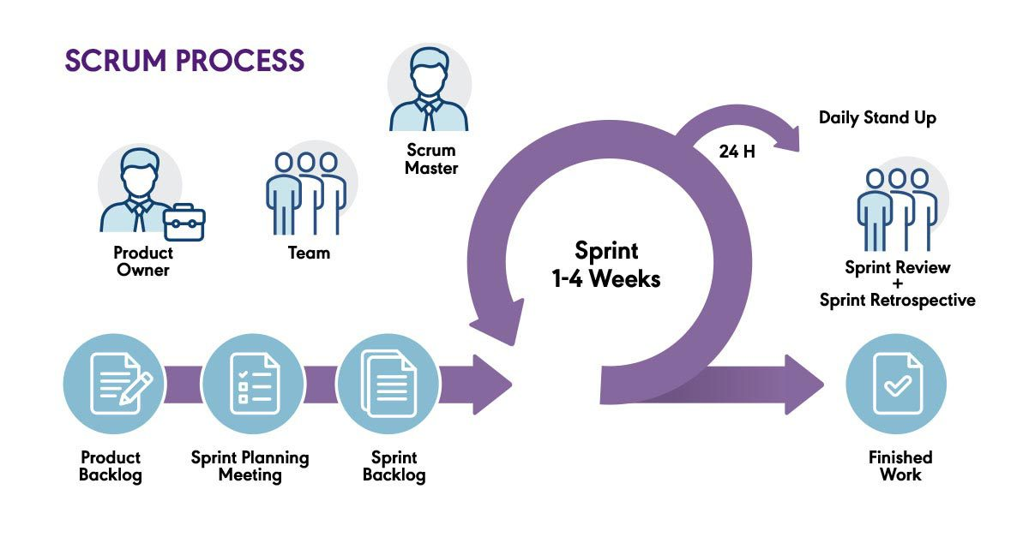

**Key Components of Scrum:**

1. **Roles in Scrum:**

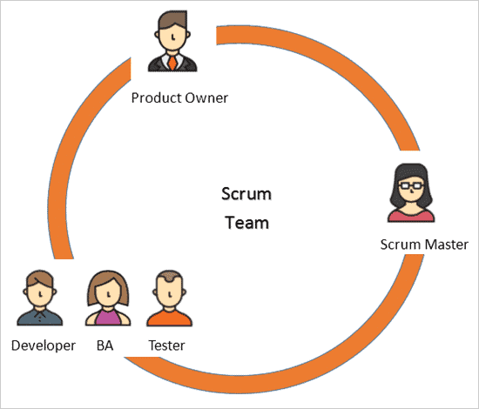

* **Product Owner:**  
  The Product Owner is responsible for defining what the product should do. They maintain the **Product Backlog**, which is a prioritized list of features, bug fixes, and improvements. The Product Owner decides which items are most important and should be worked on first to maximize value for customers and the business.
* **Scrum Master:**  
  The Scrum Master acts as a coach and facilitator for the team. They ensure that everyone understands and follows Scrum practices. The Scrum Master helps remove any obstacles or issues that might slow down the team’s progress. They also protect the team from distractions and interruptions.
* **Development Team:**  
  This is a self-organizing group of professionals who design, develop, test, and deliver the product. The team decides how best to complete the work within the Sprint and collaborates closely to achieve the Sprint goals.

1. **Scrum Artifacts :**

Artifacts in Scrum are important tools or documents that provide transparency and keep everyone aligned on what is being built, what work remains, and what has been completed.

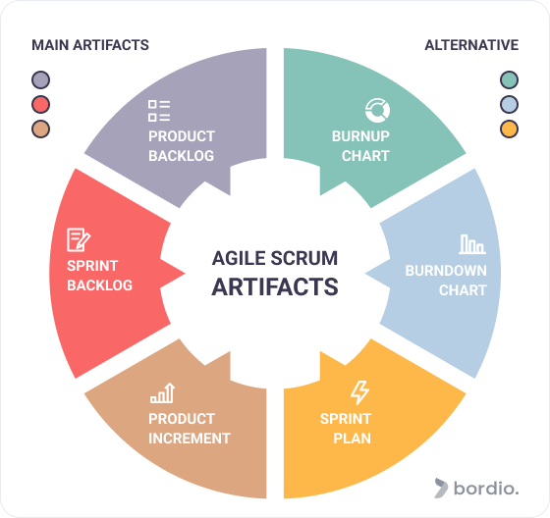

**1.Product Backlog :**

* **What it is:**The Product Backlog is a prioritized list of everything that might be needed in the product. It contains features, bug fixes, enhancements, technical tasks — basically, all the work that could be done to improve the product.
* **Who owns it:**The Product Owner is responsible for creating, updating, and prioritizing the Product Backlog.
* **Why it matters:**It acts as the single source of truth for the team about what to work on next. The items are ordered by priority, so the team always works on the most valuable and important things first.

**2.Sprint Backlog:**

* **What it is:**The Sprint Backlog is a subset of the Product Backlog — the list of tasks and product backlog items that the team commits to completing during a specific Sprint.
* **Who owns it:**The Development Team owns the Sprint Backlog. They select the items from the Product Backlog during Sprint Planning and break those into smaller tasks they can complete within the Sprint.
* **Why it matters:**It gives a clear and focused plan for the Sprint, showing exactly what the team will deliver by the end of the Sprint.

**3.Increment:**

* **What it is:**The Increment is the sum of all Product Backlog items completed during a Sprint plus all previous increments. In simple terms, it is the working product or feature that is ready to be used or shipped.
* **Who owns it:**The whole Scrum Team works to produce the Increment, but the Development Team is responsible for ensuring that the Increment meets the agreed quality standards.
* **Why it matters:**The Increment must be “Done” — meaning it has been fully developed, tested, and meets the team’s Definition of Done (quality checklist). This ensures that every Sprint produces a usable, reliable product.

**3. Scrum Events (Meetings)**

* **Sprint:**  
  A Sprint is a fixed time-box, usually between 2 and 4 weeks, during which the team works on the selected Sprint Backlog items to create a usable product increment.
* **Sprint Planning:**  
  This meeting happens at the start of each Sprint. The team collaborates with the Product Owner to select what work will be done and plans how to complete it. They define the Sprint Goal and break down work into smaller tasks.
* **Daily Scrum (Daily Standup):**  
  A short daily meeting (around 15 minutes) where each team member shares:
  + What they did since the last meeting
  + What they plan to do before the next meeting
  + Any obstacles or issues blocking their wor
* **Sprint Review:**  
  Held at the end of the Sprint, this meeting allows the team to demonstrate the completed work to stakeholders and get feedback. This helps the Product Owner adjust the Product Backlog based on real user input.
* **Sprint Retrospective:**  
  After the Sprint Review, the team meets to reflect on how the Sprint went. They discuss what worked well, what didn’t, and agree on improvements to implement in the next Sprint to become more effective.

**Why Use Scrum?**

* **Faster delivery:** Scrum promotes delivering small, functional pieces of the product frequently, so users get value early and often.
* **Better adaptability:** Because work is done in short cycles, it’s easier to change direction based on customer feedback or market needs.
* **Improved communication:** Daily meetings and regular reviews keep everyone informed and aligned.
* **Higher quality:** Continuous testing and reviews help catch issues early, resulting in a better product.
* **Team empowerment:** Scrum encourages self-management and collaboration, boosting motivation and creativity.
* **Continuous improvement:** The team always looks for ways to improve how they work through regular retrospectives.